# 2025 Local CIL Funding - Guidance Notes for Applicants

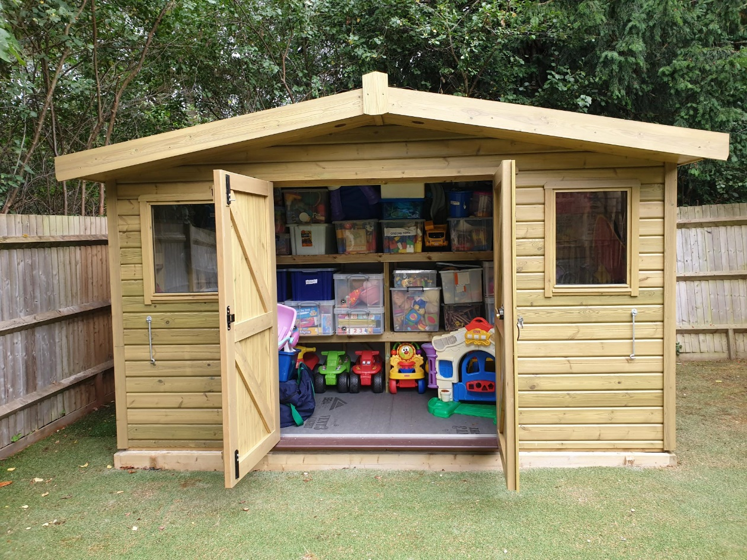

New larger and watertight storage shed at St Mary’s Community Hall, Long Ditton – Local CIL Funding 2024.

Please use the Guidance Notes to help you complete the 2025 Local CIL Funding Application Form.



Contents

2025 Local CIL Funding - Guidance Notes for Applicants 1

Introduction 3

What is CIL and how is it allocated? 3

Criteria 4

What type of projects have been funded? 4

Who can apply? 4

What is not eligible? 4

How much can I apply for? 5

What is the deadline for applications? 5

Completing the form 5

Questions 1-3 6

Questions 4-5 6

Questions 6-7 6

Question 8 6

Question 9 6

Question 10 7

Questions 11-14 7

Questions 15-17 7

Questions 18-19 8

Questions 20-21 8

Declaration 9

What happens after submitting an application 9

Local Spending Boards 9

Payment of CIL funding 10

Publicity 10

## Introduction

This guidance aims to assist those completing the Community Infrastructure Levy (CIL) Local Funding Application Form. To discuss a potential project or for further guidance, please contact the CIL Team on 01372 474791 or email [cil@elmbridge.gov.uk](mailto:cil@elmbridge.gov.uk).

### What is CIL and how is it allocated?

The Community Infrastructure Levy is a charge collected on new development built in the borough and the funds raised are made available to be spent on infrastructure projects. The funds are used either for local infrastructure or for infrastructure with a broader strategic advantage to the borough. The CIL funding pots for each area are determined by the level of development in that area.

Each year, an initial 5% of CIL funds collected are retained for administration purposes. The council then allocates 15% of the funds to the local communities where the development took place, to be spent on smaller infrastructure schemes.

Elmbridge has six settlement area committees, known as Local Spending Boards, and local Councillors decide on how local CIL funds will be allocated. Council funding for projects can only be up to the amount of funds available for the settlement area. For Claygate, the local portion of CIL funds is passed directly to the Parish Council to be allocated in accordance with the CIL regulations.

The Local Spending Boards are:

* East & West Molesey
* Esher and Hersham
* Oatlands & Burwood Park, Weybridge Riverside & Weybridge St George's Hill
* Cobham & Downside, Oxshott & Stoke D'Abernon
* Walton-On-Thames
* Hinchley Wood & Weston Green, Long Ditton & Thames Ditton

The remaining 80% of CIL funds are allocated towards strategic borough-wide infrastructure in conjunction with infrastructure providers to deliver improvements and enable growth.

## Criteria

The regulations that govern how CIL is spent require that this local CIL spending be allocated towards:

* **funding the provision, improvement, replacement, operation, or maintenance of infrastructure to support the development of its area.**

These definitions allow the local community to consider quite broadly what is needed to help mitigate the impacts of development in their area. The definition of infrastructure as per the regulations is broad and includes roads and other transport infrastructure, flood defences, schools and other educational facilities, medical facilities, sporting and recreational facilities and open spaces.

### What type of projects have been funded?

Examples of successful local CIL applications include:

* Improvements to state schools and education facilities
* Improvement to public and community spaces
* Footpath and countryside access
* Medical and sporting facilities

### Who can apply?

We expect applications to come from non-profit organisations and those organisations should already have a bank account in place under their name, funds cannot be paid into personal account. Applicants may include statutory infrastructure providers, state schools, community groups and registered charities. Applications by membership organisations must be able to demonstrate a wider community benefit. Given that CIL is public funding, any new or improved facilities should be accessible to a range of people within the community. Applications must be received from the delivery organisation, rather than an individual.

### What is not eligible?

* Projects that have commenced or completed prior to a funding decision being made by the Local Spending Board
* Ongoing revenue costs for a project
* Annual maintenance or repair
* Projects promoting a political party
* Projects that conflict with existing council policies
* VAT that the organisation can recover
* External costs such as planning application, architect, project manager, employee, fees / costs related to the project

Please note it may be determined that some projects are better funded through other funding sources.

### How much can I apply for?

Applications can be made for full or part funding of a project. If a project has separate elements / deliverable phases, it is beneficial to break down the project and list the elements / phases and associated cost in the application form. It is also beneficial to list whether any element / phase of a project is dependent on another and if there is any preference for funding of these.

If other forms of funding have been sought but unsuccessful, please provide details within the application. Evidence may be requested that other sources of funding have been sought.

When making an application, applicants are asked to take into consideration the amount available in the local funding pot. These details are published on the council’s website alongside these Guidance Notes.

### What is the deadline for applications?

This year the round opens on **Monday 3 February 2025** and applications for this spending round must be completed and submitted by **midnight on Sunday 16 March 2025.** Applications received after this date will not be considered.

Completed application forms and supporting details should be emailed to [cil@elmbridge.gov.uk](mailto:cil@elmbridge.gov.uk).

If you wish to provide an application form and supporting evidence that is not electronic, please send to: Infrastructure Delivery Coordinator, Planning Policy, Elmbridge Borough Council, Civic Centre, High Street, Esher, Surrey KT10 9SD.

## Completing the form

The following provides further guidance when answering the questions in the application form.

### Questions 1-3

The named contact from the organisation involved will need to sign the declaration at the end of the form. We will send all correspondence about this application to the main contact listed on the form.

### Questions 4-5

Please provide information on the legal status of your organisation. The type of organisations that might be applying include:

* Community or voluntary groups
* Community Interest Companies
* Charities or trusts
* Public sector organisations

If a registered charity, please provide the registration number. You must let us know if you are able to reclaim VAT as the council will not cover the costs for VAT if they can be claimed back by the applicant. Failing to declare the ability to re-claim VAT will void the application at any stage.

The organisation must already have a bank account in place under the name of the organisation.

### Questions 6-7

Please indicate the name of the project as well as the address where the infrastructure is located (including postcode) and provide a map showing the exact location of the project. The location of the project / infrastructure will determine which Local Spending Board considers the application for funding. If any project is found to be located outside of the Borough, it will be automatically rejected.

### Question 8

Please give a precise description of the project proposal, and how it will be implemented.

### Question 9

Please provide written evidence, if required, that you have secured consent from the landowner or landlord for the project to be undertaken.

### Question 10

Indicate the amount of money you would like to apply for including a breakdown of what the amount will fund. If there are multiple elements within an application, or if it can be broken down into components, please prioritise these within your form. Funding will only cover the physical implementation of the scheme and should not be used to cover any external costs such as planning application, architect, building control, project manager, employee, fees / costs etc.

Any funding will be conditional on the submission of 3 competitive quotes for the work that you are applying for. The quotes must be submitted with the application form to be validated. If the project requires specialist or bespoke work, and three providers in the area do not exist, please state this on the application form and provide the one quote.

### Questions 11-14

Please confirm the funding breakdown and the amount of CIL funding being sought including why you are seeking CIL funding and details on how it would be used and the benefits it will bring.

Let us know if there are contributions from third parties - i.e., other organisations or grant schemes. Please show what contribution your organisation is putting into the project. You must let us know if you are applying for funding from any other body and you must inform us if any applications are successful whilst this bid is under review. Please also let us know if the organisation has previously received CIL or other sources of funding from Elmbridge Borough Council or from another body.

### Questions 15-17

Please highlight the pressures that the project is addressing. Set out below are some infrastructure pressures that have been identified but there will also be other local priorities.

* Transport schemes including cycling infrastructure, bus corridor, junction, safety around schools and schemes supportive of air quality improvements
* Flood and drainage improvements
* Improvements to community and open spaces
* Indoor / outdoor sport provision
* School provision including playground, library, safety measures
* Primary Healthcare facilities
* Climate resilient/sustainable infrastructure

These pressures have been identified in existing documents which are available on our [webpage](https://www.elmbridge.gov.uk/planning/local-plan/local-plan-supporting-evidence/) (see Infrastructure Delivery Plan May 2022) and may provide additional information to strengthen your application.

The council declared a climate emergency in July 2019 and has since developed a Carbon Management and Reduction Plan 2020-2030 to reduce our organisational carbon emissions and reach the target of being a carbon neutral organisation by 2030. Carbon neutrality also needs to be considered outside of our organisation, therefore within your application please demonstrate how you have considered climate change impacts, carbon reduction and/or sustainability for your project. The details provided should be proportionate to the scale of the project and some points to consider are: How has the sustainability and carbon impacts of your project been considered and addressed; How does your project help to tackle climate change and what makes it sustainable; How are you planning to reduce or mitigate any negative impacts.

You can highlight any support for the project from the local community and you can include letters of support to the application.

You may also want to make your ward Councillors aware of your intention to apply. You can find their details under [“My Neighbourhood”](https://emaps.elmbridge.gov.uk/myElmbridge.aspx?tab=0) on the Elmbridge Borough Council website homepage.

### Questions 18-19

You must demonstrate that the project is deliverable and is able to be started within a year of the funding decision. You must also explain how long-term revenue commitments will be met in order to show that the project is sustainable in the long term.

### Questions 20-21

If the organisation is not in the public sector, please provide a copy of the organisation’s most recent audited accounts. This is to ensure that decision makers are aware of the level of unrestricted funds in the organisation’s reserves. This information will be treated as confidential and will only be shared with local Councillors on the relevant Local Spending Board for decision making purposes.

It is the applicant’s responsibility to determine if planning permission is required for their project. If planning permission is required for the scheme, we recommend that you obtain planning permission before applying for CIL funding.

Alternatively, please provide details on what stage of the process you have reached. Please note that planning permission costs should not be included within the costing of the project to be funded through CIL.

### Declaration

Please make sure you read the declaration carefully, sign the form and return it. Any other organisation that will be involved with delivery should also sign the declaration.

## What happens after submitting an application

We will confirm receipt of your application and whether all required information has been received. We may ask you to provide further information, if necessary, to validate the application.

Applicants who have applied by the closing date will have a further 4 weeks to provide any outstanding details needed for a valid application. We will let you know the deadline for submitting these additional details. Failure to provide the requested details by the deadline will result in the application being invalid and not being considered.

This year, the Local Spending Boards will be held in June-July 2025.

### Local Spending Boards

Local Councillors will make the final decision regarding CIL allocation at the Local Spending Board. Prior to the meeting, each valid application will be carefully reviewed, and projects will be scored and prioritised for funding in the Officer’s report. Officers will make clear recommendations for Councillors to consider and apply to their decision-making process.

For sustainability purposes, the number of documents published as part of the agenda will be limited where necessary with the remainder circulated electronically to Councillors.

Applicants may be invited to a 3-minute oral presentation to introduce their project. No PowerPoint or additional documents will be accepted at the meeting. Following the presentation, Councillors may ask questions or seek clarifications from the applicant regarding the project.

The final decision to fund, partially fund or refuse the project, subject to sufficient funds in the Local CIL pot, will be taken during the meeting. Applicant will be formally notified of the decision in writing within a few weeks of the meeting.

### Payment of CIL funding

Successful projects must be able to commence within the twelve months following the relevant Spending Board. Full terms and conditions will be sent along with the award letter to successful applicants a few weeks after the relevant Spending Board decision.

Where relevant, the CIL funding will be conditional upon the applicant obtaining any necessary building regulations and/or planning permission and any other consents or permissions as may be required.

Payment will be made after completion of the project to the satisfaction of the Applicant and the Council, as per the application details and, after submission of verifiable invoices. The original invoices/receipts need to be submitted via email to the council as proof of expenditure. You must have a bank account in the name of the organisation into which the council will pay the funding.

The CIL funding is a one-off payment and will not result in any future revenue commitment by the council. Any maintenance responsibility, revenue liability or ongoing future funding related to the application lies with the applicant. The council may require documentary evidence of how such responsibilities and any future funding will be met. If the Applicant is unable to meet these requirements, the council reserves the right to withhold, vary or terminate payment of funding /or require any or all the CIL award to be repaid.

### Publicity

The applicant will need to agree to publicise the support of Elmbridge Borough Council and the council reserves the right to use images of the project resulting from the award of the CIL funding as part of any publicity material that it may wish.

The assessment process is competitive and not all applications will be funded. There is no right of appeal against the decision.